Private Sushi Lessons with Queen Of Sushi , Madame Saito
Make your own Sushi and eat what you make.
Address: 122-124 Lombard St, Philadelphia, PA 19147
Phone: (215) 922 - 2515
Email: madamesaito@gmail.com
Cell: (215) 815-8266

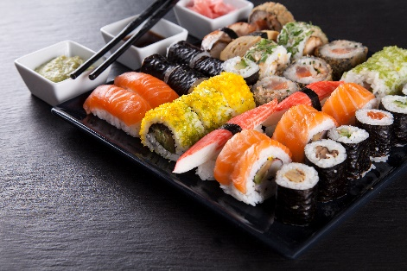

Level 1 Private Sushi Class : Two hours for 2 people $250
Group Of 10 or more $100 per person
- Learn how to make sushi rice
- How to roll sushi maki and variety of different styles of rolls such as Hosomaki, Uramaki, Hand Rolls, Temaki, Futomaki super rolls.
- Learn how to cut each rolls into pieces
Level 2 Private Sushi Class: Three hours $350 for two people
Group of 10 or more $150 per person
- You will learn everything from level 1 plus sushi Nigiri , rolling makis and , tuna, salmon, eel, spicy tuna, ect.
Master Course Sushi Class : Three hours $500 per two people
Group of 10 or more $200 per person
- Making Sushi rolls
- Making sushi nigiri
- Learn how to prepare fish for sushi and sashimi, slice fish technique.
Call now to schedule your private lesson (215)922-2515

